






Apply catering control principles and procedures
D1.HCC.CL2.01
Trainer Guide

Apply catering control principles and procedures

D1.HCC.CL2.01

Trainer Guide




Project Base
William Angliss Institute of TAFE
555 La Trobe Street
Melbourne 3000 Victoria
Telephone: | (03) 9606 2111
Facsimile: | (03) 9670 1330
Acknowledgements
Project Director: | Wayne Crosbie
Chief Writer: | Alan Hickman
Subject Writer: | Garry Blackburn
Project Manager: | Alan Maguire
Editor: | Jim Irwin
DTP/Production: | Daniel Chee, Mai Vu, Kaly Quach

The Association of Southeast Asian Nations (ASEAN) was established on 8 August 1967. The Member States of the Association are Brunei Darussalam, Cambodia, Indonesia, Lao PDR, Malaysia, Myanmar, Philippines, Singapore, Thailand and Viet Nam.
The ASEAN Secretariat is based in Jakarta, Indonesia.
General Information on ASEAN appears online at the ASEAN Website: www.asean.org.
All text is produced by William Angliss Institute of TAFE for the ASEAN Project on “Toolbox Development for Front Office, Food and Beverage Services and Food Production Divisions”.
This publication is supported by the Australian Government’s aid program through the ASEAN-Australia Development Cooperation Program Phase II (AADCP II).
Copyright: Association of Southeast Asian Nations (ASEAN) 2013.
All rights reserved.
Disclaimer
Every effort has been made to ensure that this publication is free from errors or omissions. However, you should conduct your own enquiries and seek professional advice before relying on any fact, statement or matter contained in this book. The ASEAN Secretariat and William Angliss Institute of TAFE are not responsible for any injury, loss or damage as a result of material included or omitted from this course. Information in this module is current at the time of publication. Time of publication is indicated in the date stamp at the bottom of each page.
Some images appearing in this resource have been purchased from stock photography suppliers Shutterstock and iStockphoto and other third party copyright owners and as such are non-transferable and non-exclusive. Clip arts, font images and illustrations used are from the Microsoft Office Clip Art and Media Library. Some images have been provided by and are the property of William Angliss Institute.
Additional images have been sourced from Flickr and SKC and are used under Creative Commons licence: http://creativecommons.org/licenses/by/2.0/deed.en
File name: TG_Apply_catering_control_prin_&_proc_FN_020214





Table of Contents
Competency Based Training (CBT) and assessment - An introduction for trainers 1
Competency standard 11
Notes and PowerPoint slides 17
Recommended training equipment 37
Instructions for Trainers for using PowerPoint – Presenter View 39
Appendix – ASEAN acronyms 41

Competency Based Training (CBT) and assessment - An introduction for trainers

Competency
Competency refers to the ability to perform particular tasks and duties to the standard of performance expected in the workplace.
Competency requires the application of specified knowledge, skills and attitudes relevant to effective participation, consistently over time and in the workplace environment.
The essential skills and knowledge are either identified separately or combined.
Knowledge identifies what a person needs to know to perform the work in an informed and effective manner.
Skills describe the application of knowledge to situations where understanding is converted into a workplace outcome.
Attitude describes the founding reasons behind the need for certain knowledge or why skills are performed in a specified manner.
Competency covers all aspects of workplace performance and involves:
- Performing individual tasks
- Managing a range of different tasks
- Responding to contingencies or breakdowns
- Dealing with the responsibilities of the workplace
- Working with others.

Unit of Competency
Like with any training qualification or program, a range of subject topics are identified that focus on the ability in a certain work area, responsibility or function.
Each manual focuses on a specific unit of competency that applies in the hospitality workplace.
In this manual a unit of competency is identified as a ‘unit’.
Each unit of competency identifies a discrete workplace requirement and includes:
- Knowledge and skills that underpin competency
- Language, literacy and numeracy
- Occupational health and safety requirements.
Each unit of competency must be adhered to in training and assessment to ensure consistency of outcomes.

Element of Competency
An element of competency describes the essential outcomes within a unit of competency.
The elements of competency are the basic building blocks of the unit of competency. They describe in terms of outcomes the significant functions and tasks that make up the competency.
In this manual elements of competency are identified as an ‘element’.

Performance criteria
Performance criteria indicate the standard of performance that is required to demonstrate achievement within an element of competency. The standards reflect identified industry skill needs.
Performance criteria will be made up of certain specified skills, knowledge and attitudes.

Learning
For the purpose of this manual learning incorporates two key activities:
- Training
- Assessment.
Both of these activities will be discussed in detail in this introduction.
Today training and assessment can be delivered in a variety of ways. It may be provided to participants:
- On-the-job – in the workplace
- Off-the-job – at an educational institution or dedicated training environment
- As a combination of these two options.
No longer is it necessary for learners to be absent from the workplace for long periods of time in order to obtain recognised and accredited qualifications.

Learning Approaches
This manual will identify two avenues to facilitate learning:
Competency Based Training (CBT)
This is the strategy of developing a participant’s competency.
Educational institutions utilise a range of training strategies to ensure that participants are able to gain the knowledge and skills required for successful:
- Completion of the training program or qualification
- Implementation in the workplace.
The strategies selected should be chosen based on suitability and the learning styles of participants.

Competency Based Assessment (CBA)
This is the strategy of assessing competency of a participant.
Educational institutions utilise a range of assessment strategies to ensure that participants are assessed in a manner that demonstrates validity, fairness, reliability, flexibility and fairness of assessment processes.

Flexibility in Learning
It is important to note that flexibility in training and assessment strategies is required to meet the needs of participants who may have learning difficulties. The strategies used will vary, taking into account the needs of individual participants with learning difficulties. However they will be applied in a manner which does not discriminate against the participant or the participant body as a whole.
Catering for Participant Diversity
Participants have diverse backgrounds, needs and interests. When planning training and assessment activities to cater for individual differences, trainers and assessors should:
- Consider individuals’ experiences, learning styles and interests
- Develop questions and activities that are aimed at different levels of ability
- Modify the expectations for some participants
- Provide opportunities for a variety of forms of participation, such as individual, pair and small group activities
- Assess participants based on individual progress and outcomes.
The diversity among participants also provides a good reason for building up a learning community in which participants support each other’s learning.
Participant Centred Learning
This involves taking into account structuring training and assessment that:
- Builds on strengths – Training environments need to demonstrate the many positive features of local participants (such as the attribution of academic success to effort, and the social nature of achievement motivation) and of their trainers (such as a strong emphasis on subject disciplines and moral responsibility). These strengths and uniqueness of local participants and trainers should be acknowledged and treasured
- Acknowledges prior knowledge and experience – The learning activities should be planned with participants’ prior knowledge and experience in mind
- Understands learning objectives – Each learning activity should have clear learning objectives and participants should be informed of them at the outset. Trainers should also be clear about the purpose of assignments and explain their significance to participants
- Teaches for understanding – The pedagogies chosen should aim at enabling participants to act and think flexibly with what they know
- Teaches for independent learning – Generic skills and reflection should be nurtured through learning activities in appropriate contexts of the curriculum. Participants should be encouraged to take responsibility for their own learning
- Enhances motivation – Learning is most effective when participants are motivated. Various strategies should be used to arouse the interest of participants
- Makes effective use of resources – A variety of teaching resources can be employed as tools for learning
- Maximises engagement – In conducting learning activities, it is important for the minds of participants to be actively engaged
- Aligns assessment with learning and teaching – Feedback and assessment should be an integral part of learning and teaching
- Caters for learner diversity – Trainers should be aware that participants have different characteristics and strengths and try to nurture these rather than impose a standard set of expectations.
Active Learning
The goal of nurturing independent learning in participants does not imply that they always have to work in isolation or solely in a classroom. On the contrary, the construction of knowledge in tourism and hospitality studies can often best be carried out in collaboration with others in the field. Sharing experiences, insights and views on issues of common concern, and working together to collect information through conducting investigative studies in the field (active learning) can contribute a lot to their eventual success.
Active learning has an important part to play in fostering a sense of community in the class. First, to operate successfully, a learning community requires an ethos of acceptance and a sense of trust among participants, and between them and their trainers. Trainers can help to foster acceptance and trust through encouragement and personal example, and by allowing participants to take risks as they explore and articulate their views, however immature these may appear to be. Participants also come to realise that their classmates (and their trainers) are partners in learning and solving.
Trainers can also encourage cooperative learning by designing appropriate group learning tasks, which include, for example, collecting background information, conducting small-scale surveys, or producing media presentations on certain issues and themes. Participants need to be reminded that, while they should work towards successful completion of the field tasks, developing positive peer relationships in the process is an important objective of all group work.

Competency Based Training (CBT)
Principle of Competency Based Training
Competency based training is aimed at developing the knowledge, skills and attitudes of participants, through a variety of training tools.
Training Strategies
The aims of this curriculum are to enable participants to:
- Undertake a variety of subject courses that are relevant to industry in the current environment
- Learn current industry skills, information and trends relevant to industry
- Learn through a range of practical and theoretical approaches
- Be able to identify, explore and solve issues in a productive manner
- Be able to become confident, equipped and flexible managers of the future
- Be ‘job ready’ and a valuable employee in the industry upon graduation of any qualification level.
To ensure participants are able to gain the knowledge and skills required to meet competency in each unit of competency in the qualification, a range of training delivery modes are used.
Types of Training
In choosing learning and teaching strategies, trainers should take into account the practical, complex and multi-disciplinary nature of the subject area, as well as their participant’s prior knowledge, learning styles and abilities.
Training outcomes can be attained by utilising one or more delivery methods:
Lecture/Tutorial
This is a common method of training involving transfer of information from the trainer to the participants. It is an effective approach to introduce new concepts or information to the learners and also to build upon the existing knowledge. The listener is expected to reflect on the subject and seek clarifications on the doubts.
Demonstration
Demonstration is a very effective training method that involves a trainer showing a participant how to perform a task or activity. Through a visual demonstration, trainers may also explain reasoning behind certain actions or provide supplementary information to help facilitate understanding.
Group Discussions
Brainstorming in which all the members in a group express their ideas, views and opinions on a given topic. It is a free flow and exchange of knowledge among the participants and the trainer. The discussion is carried out by the group on the basis of their own experience, perceptions and values. This will facilitate acquiring new knowledge. When everybody is expected to participate in the group discussion, even the introverted persons will also get stimulated and try to articulate their feelings.
The ideas that emerge in the discussions should be noted down and presentations are to be made by the groups. Sometimes consensus needs to be arrived at on a given topic. Group discussions are to be held under the moderation of a leader guided by the trainer. Group discussion technique triggers thinking process, encourages interactions and enhances communication skills.
Role Play
This is a common and very effective method of bringing into the classroom real life situations, which may not otherwise be possible. Participants are made to enact a particular role so as to give a real feel of the roles they may be called upon to play. This enables participants to understand the behaviour of others as well as their own emotions and feelings. The instructor must brief the role players on what is expected of them. The role player may either be given a ready-made script, which they can memorise and enact, or they may be required to develop their own scripts around a given situation. This technique is extremely useful in understanding creative selling techniques and human relations. It can be entertaining and energising and it helps the reserved and less literate to express their feelings.

Simulation Games
When trainees need to become aware of something that they have not been conscious of, simulations can be a useful mechanism. Simulation games are a method based on "here and now" experience shared by all the participants. The games focus on the participation of the trainees and their willingness to share their ideas with others. A "near real life" situation is created providing an opportunity to which they apply themselves by adopting certain behaviour. They then experience the impact of their behaviour on the situation. It is carried out to generate responses and reactions based on the real feelings of the participants, which are subsequently analysed by the trainer.
While use of simulation games can result in very effective learning, it needs considerable trainer competence to analyse the situations.
Individual /Group Exercises
Exercises are often introduced to find out how much the participant has assimilated. This method involves imparting instructions to participants on a particular subject through use of written exercises. In the group exercises, the entire class is divided into small groups, and members are asked to collaborate to arrive at a consensus or solution to a problem.
Case Study
This is a training method that enables the trainer and the participant to experience a real life situation. It may be on account of events in the past or situations in the present, in which there may be one or more problems to be solved and decisions to be taken. The basic objective of a case study is to help participants diagnose, analyse and/or solve a particular problem and to make them internalise the critical inputs delivered in the training. Questions are generally given at the end of the case study to direct the participants and to stimulate their thinking towards possible solutions. Studies may be presented in written or verbal form.
Field Visit
This involves a carefully planned visit or tour to a place of learning or interest. The idea is to give first-hand knowledge by personal observation of field situations, and to relate theory with practice. The emphasis is on observing, exploring, asking questions and understanding. The trainer should remember to brief the participants about what they should observe and about the customs and norms that need to be respected.
Group Presentation
The participants are asked to work in groups and produce the results and findings of their group work to the members of another sub-group. By this method participants get a good picture of each other's views and perceptions on the topic and they are able to compare them with their own point of view. The pooling and sharing of findings enriches the discussion and learning process.
Practice Sessions
This method is of paramount importance for skills training. Participants are provided with an opportunity to practice in a controlled situation what they have learnt. It could be real life or through a make-believe situation.

Games
This is a group process and includes those methods that involve usually fun-based activity, aimed at conveying feelings and experiences, which are everyday in nature, and applying them within the game being played. A game has set rules and regulations, and may or may not include a competitive element. After the game is played, it is essential that the participants be debriefed and their lessons and experiences consolidated by the trainer.
Research
Trainers may require learners to undertake research activities, including online research, to gather information or further understanding about a specific subject area.

Competency Based Assessment (CBA)
Principle of Competency Based Assessment
Competency based assessment is aimed at compiling a list of evidence that shows that a person is competent in a particular unit of competency.
Competencies are gained through a multitude of ways including:
- Training and development programs
- Formal education
- Life experience
- Apprenticeships
- On-the-job experience
- Self-help programs.
All of these together contribute to job competence in a person. Ultimately, assessors and participants work together, through the ‘collection of evidence’ in determining overall competence.
This evidence can be collected:
- Using different formats
- Using different people
- Collected over a period of time.
The assessor, who is ideally someone with considerable experience in the area being assessed, reviews the evidence and verifies the person as being competent or not.
Flexibility in Assessment
Whilst allocated assessment tools have been identified for this subject, all attempts are made to determine competency and suitable alternate assessment tools may be used, according to the requirements of the participant.
The assessment needs to be equitable for all participants, taking into account their cultural and linguistic needs.
Competency must be proven regardless of:
- Language
- Delivery Method
- Assessment Method.
Assessment Objectives
The assessment tools used for subjects are designed to determine competency against the ‘elements of competency’ and their associated ‘performance criteria’.
The assessment tools are used to identify sufficient:
- Knowledge, including underpinning knowledge
- Skills
- Attitudes
Assessment tools are activities that trainees are required to undertake to prove participant competency in this subject.
All assessments must be completed satisfactorily for participants to obtain competence in this subject. There are no exceptions to this requirement, however, it is possible that in some cases several assessment items may be combined and assessed together.
Types of Assessment
Allocated Assessment Tools
There are a number of assessment tools that are used to determine competency in this subject:
- Work projects
- Written questions
- Oral questions
- Third Party Report
- Observation Checklist.
Instructions on how assessors should conduct these assessment methods are explained in the Assessment Manuals.
Alternative Assessment Tools
Whilst this subject has identified assessment tools, as indicated above, this does not restrict the assessor from using different assessment methods to measure the competency of a participant.
Evidence is simply proof that the assessor gathers to show participants can actually do what they are required to do.
Whilst there is a distinct requirement for participants to demonstrate competency, there are many and diverse sources of evidence available to the assessor.
Ongoing performance at work, as verified by a supervisor or physical evidence, can count towards assessment. Additionally, the assessor can talk to customers or work colleagues to gather evidence about performance.
A range of assessment methods to assess competency include:
- Practical demonstrations
- Practical demonstrations in simulated work conditions
- Problem solving
- Portfolios of evidence
- Critical incident reports
- Journals
- Oral presentations
- Interviews
- Videos
- Visuals: slides, audio tapes
- Case studies
- Log books
- Projects
- Role plays
- Group projects
- Group discussions
- Examinations.
Recognition of Prior Learning
Recognition of Prior Learning is the process that gives current industry professionals who do not have a formal qualification, the opportunity to benchmark their extensive skills and experience against the standards set out in each unit of competency/subject.
Also known as a Skills Recognition Audit (SRA), this process is a learning and assessment pathway which encompasses:
- Recognition of Current Competencies (RCC)
- Skills auditing
- Gap analysis and training
- Credit transfer.
Assessing competency
As mentioned, assessment is the process of identifying a participant’s current knowledge, skills and attitudes sets against all elements of competency within a unit of competency. Traditionally in education, grades or marks were given to participants, dependent on how many questions the participant successfully answered in an assessment tool.
Competency based assessment does not award grades, but simply identifies if the participant has the knowledge, skills and attitudes to undertake the required task to the specified standard.
Therefore, when assessing competency, an assessor has two possible results that can be awarded:
- Pass Competent (PC)
- Not Yet Competent (NYC).
Pass Competent (PC)
If the participant is able to successfully answer or demonstrate what is required, to the expected standards of the performance criteria, they will be deemed as ‘Pass Competent’ (PC).
The assessor will award a ‘Pass Competent’ (PC) if they feel the participant has the necessary knowledge, skills and attitudes in all assessment tasks for a unit.
Not Yet Competent’ (NYC)
If the participant is unable to answer or demonstrate competency to the desired standard, they will be deemed to be ‘Not Yet Competent’ (NYC).
This does not mean the participant will need to complete all the assessment tasks again. The focus will be on the specific assessment tasks that were not performed to the expected standards.
The participant may be required to:
a) Undertake further training or instruction
b) Undertake the assessment task again until they are deemed to be ‘Pass Competent’.

Competency standard
UNIT TITLE: APPLY CATERING CONTROL PRINCIPLES AND PROCEDURES |  |  |  | NOMINAL HOURS: 15
UNIT NUMBER: D1.HCC.CL2.01
UNIT DESCRIPTOR: This unit deals with skills and knowledge required by cooks and chefs in a supervisor position to order, store and prepare foods to minimise wastage in commercial food production environments
ELEMENTS AND PERFORMANCE CRITERIA | UNIT VARIABLE AND ASSESSMENT GUIDE
Element 1: Apply catering control principles and procedures  - Identify the range of catering products used within the enterprise  - Use requisition/portion control effectively  - Use standard recipes correctly  - Implement ordering and stock rotation practices  - Use optimum storage conditions  Element 2: Minimise wastage  - Use trimmings of food products  - Dispose of food wastage in line with enterprise and local authorities’ requirements  - Process recyclable products to local authority requirements | Unit Variables  The Unit Variables provide advice to interpret the scope and context of this unit of competence, allowing for differences between enterprises and workplaces. It relates to the unit as a whole and facilitates holistic assessment  This unit applies to all industry sectors that apply catering control principles and procedures within the labour divisions of the hotel and travel industries and may include:  - Food Production  Range of catering products may include:  Perishable products, including fruit, vegetables, meat, seafood  Paper goods, such as wrapping, boxes, gift ware  Chemicals  Glass  Plastic products, such as disposable cups, plates, cutlery  Foam products, such as fast food packaging.
Requisition/portion control may be related to:
Scales
Measuring equipment, including spoons, jugs, buckets, rulers
Portion control.
Standard recipes should include:
Portion numbers
Portion weight
Date
Yield
Ingredients
Method of sequence
Cooking temperatures/time
Equipment.
Ordering may be related to:
First in, first out (FIFO)
Re-usable products
Storage
Availability
Par stock levels.
Storage may include:
Cool room temperature
Cool room placement
Length of time in cool storage
Freezer temperature
Length of time in freezer storage
Storage, including dry, chemical, recyclable items.
Trimmings may relate to:
Off cuts
Saleable dishes
Menu varieties.
Dispose of may relate to:
Rubbish collection
Recyclables collection
Oils
Food scraps.
Recyclable may relate to:
Glass
Plastics
Paper, cardboard
Metal
Cooking oil
Food scraps.
Assessment Guide
The following skills and knowledge must be assessed as part of this unit:
Knowledge of correct method is demonstrated for applying catering control
Overview of the relevant legislation in relation to food handling, food storage, chemical storage and general premises food safety
Ability to demonstrate safe knife handling skills, including the ability to trim and cut to industry and enterprise standards
Ability to demonstrate safe equipment/utensil practical skills
Knowledge of recycling principles.
Linkages To Other Units
Comply with workplace hygiene procedures
Implement occupational health and safety procedures
Prepare and store food
Work effectively with colleagues and customers
Maintain strategies for safe food
Present and display food products
Apply basic techniques of commercial cookery.
Critical Aspects of Assessment
Evidence of the following is essential:
Knowledge of the classifications and characteristics of applying catering control principles and the terminology used
Demonstrate safe and hygienic handling of products
Demonstrate appropriate portion control and wastage minimisation
Demonstrate safe knife skills and other associated equipment
Demonstrate ability to store foods appropriately to ensure quality and wastage minimisation.
Context of Assessment
Assessment must ensure:
Access to a range of catering establishments
Commercial food preparation area with relevant equipment
Service and presentation equipment for applying catering control
Demonstration of skills on more than one occasion.
Resource Implications
Training and assessment must include access and use to a fully equipped commercial kitchen, use of real ingredients and service equipment; and access to workplace customer service standards, procedures, policies, guidelines, tools and equipment
Assessment Methods
The following methods may be used to assess competency for this unit:
Observation of practical candidate performance
Oral and written questions
Third party reports completed by a supervisor
Project and assignment work.
Key Competencies in this Unit
Level 1 = competence to undertake tasks effectively
Level 2 = competence to manage tasks
Level 3 = competence to use concepts for evaluating
 | Key Competencies | Level | Examples
 | Collecting, organising and analysing information | 2 | Determine requirements of standard recipes and/or menu requirements; collect equipment, commodities and ingredients; read menus, recipes and task sheets; select and obtain commodities; organise ingredients and task sheets
 | Communicating ideas and information | 2 | Share information with other kitchen, floor service staff; read recipes, menus, instructions and orders
 | Planning and organising activities | 3 | Work within time constraints in a logical sequence; plan logical and efficient sequencing and timing of tasks
 | Working with others and in teams | 2 | Work cooperatively with other team members
 | Using mathematical ideas and techniques | 2 | Calculate portions; weigh and measure quantities against standard recipes and/or menu requirements
 | Solving problems | 2 | Identify and correct problems in preparing and producing products, such as ingredient quality and equipment failure
 | Using technology | 1 | Use mechanical kitchen equipment, including weighing equipment

Notes and PowerPoint slides
Slide
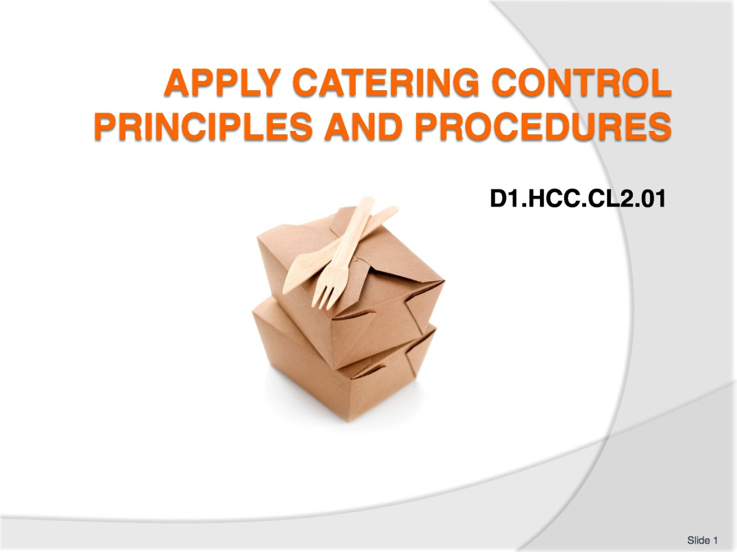
Slide No | Trainer Notes
Trainer to welcome students to the class:
Introduce self and state qualification to teach this unit
Give overview of qualifications and describe industry experience.

Slide
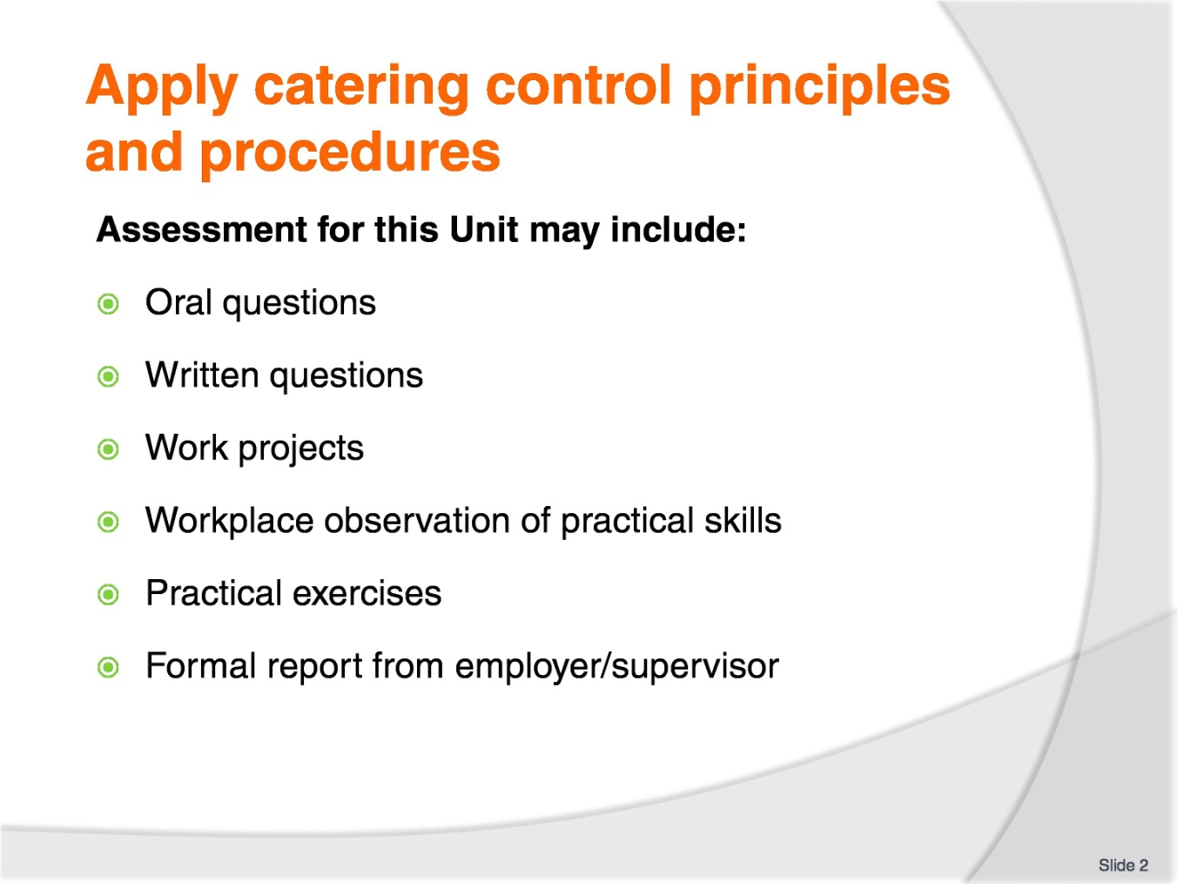
Slide No | Trainer Notes
Trainer advises students that assessment for this Unit may take several forms all of which are aimed at verifying they have achieved competency for the Unit as required.
Trainer indicates to students the methods of assessment that will be applied to them for this Unit.

Slide
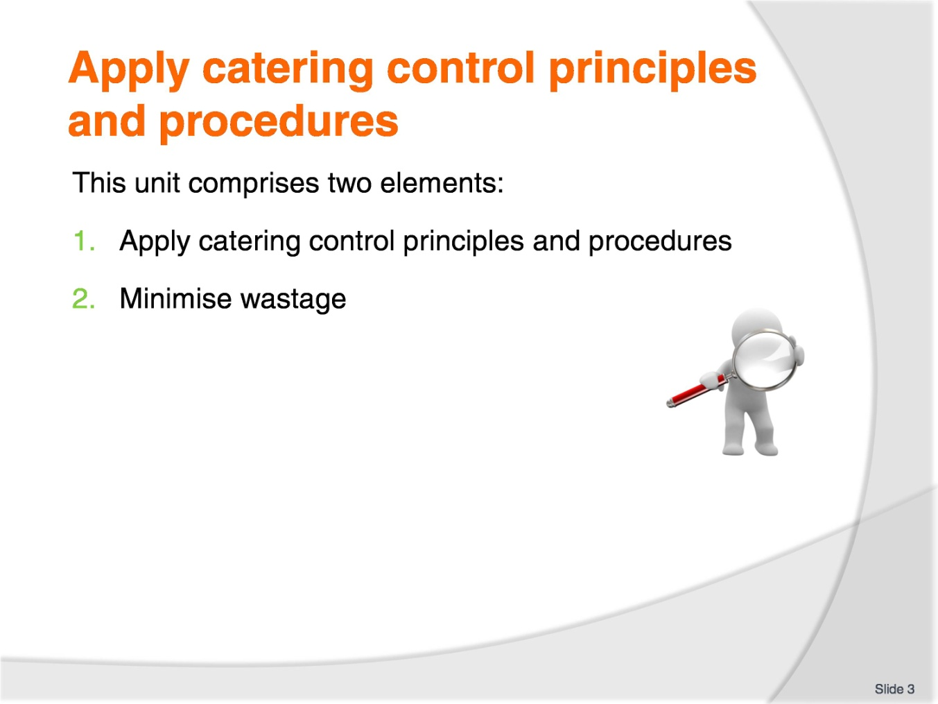
Slide No | Trainer Notes
Trainer advises students this Unit comprises two elements, as listed on the slide explaining:
Each Element comprises a number of Performance Criteria which will be identified throughout the class and explained in detail
Students can obtain more detail from their Trainee Manual
The course presents advice and information but where their workplace requirements differ to what is presented, the workplace practices and standards must be observed.

Slide
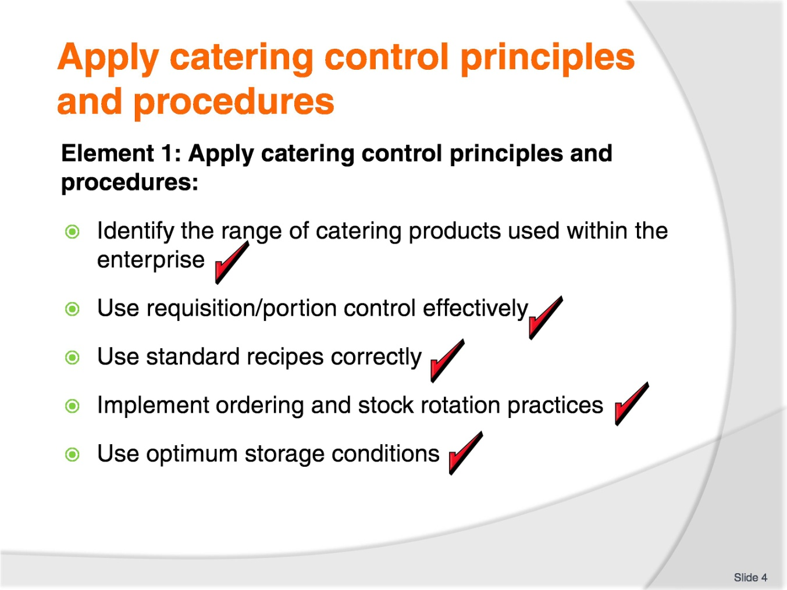
Slide No | Trainer Notes
Trainer to advise:
Trainer to relate performance criteria to element 1.
Performance criteria is the process by which the students training match the learning element.
The element is the skill.
To assess competency in the skill; the performance criteria is used to outline activities that can be used to assess competency.
The trainer should relate how the performance criteria are related to the element.
The students must be able to apply catering control principles and procedures.
The student should be able to:
Identify the range of catering products used within the enterprise
Use requisition/portion control effectively
Use standard recipes correctly
Implement ordering and stock rotation practices
Use optimum storage conditions.

Slide
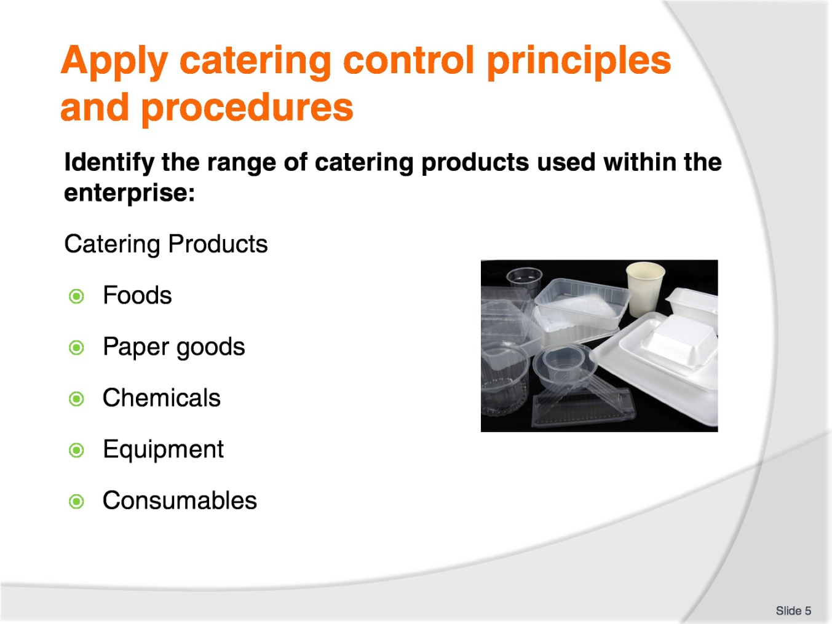
Slide No | Trainer Notes
Trainer to advise:
Catering enterprises need to have more than food to operate a business
A place for preparing the product: Kitchen
A place for selling the product made: Restaurant or outside eating area
Also required food; paper and plastic goods; cleaning chemicals; equipment both in kitchen, front of house and also cleaning and garbage disposal for both areas
Many resources are in the area of added on costs. Consumables like serviettes and take away coffee cups, cleaning chemicals, plastic wrap and aluminium foil
All costs need to be looked at and accounted. Electricity and gas. How much does it cost to operate a freezer?

Slide
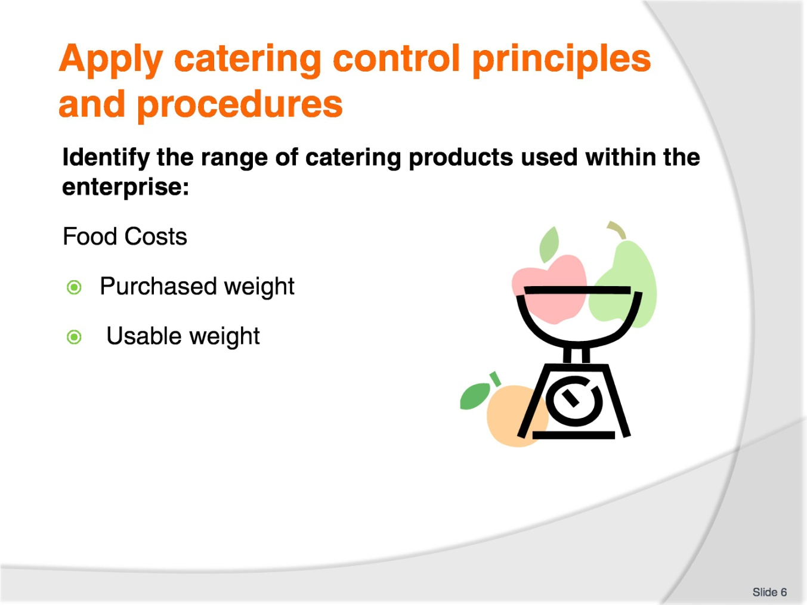
Slide No | Trainer Notes
Trainer to advise:
The amount of food in a recipe may be the amount required.
After peeling and trimming 1 kilo of carrot and cutting to size; do you have 1 kg of carrot left? NO!
What is the true cost of the carrot being used? There is usually 8-10% weight loss when cleaning and peeling carrots.
So the remaining carrots may only be 900g. After cutting to size you may be left with 750g.
750g of carrots cut to specific size result in a change of cost for the amount of usable carrots.
If the carrots were purchased for $2.50 a kilo then peeled, cleaned and trimmed and the resulting end weight is 750g, this then make the prepared carrots worth $3.34 per kilo. This does not include the cost of the labour to prepare the carrots.
Just the cost of the carrots.

Slide
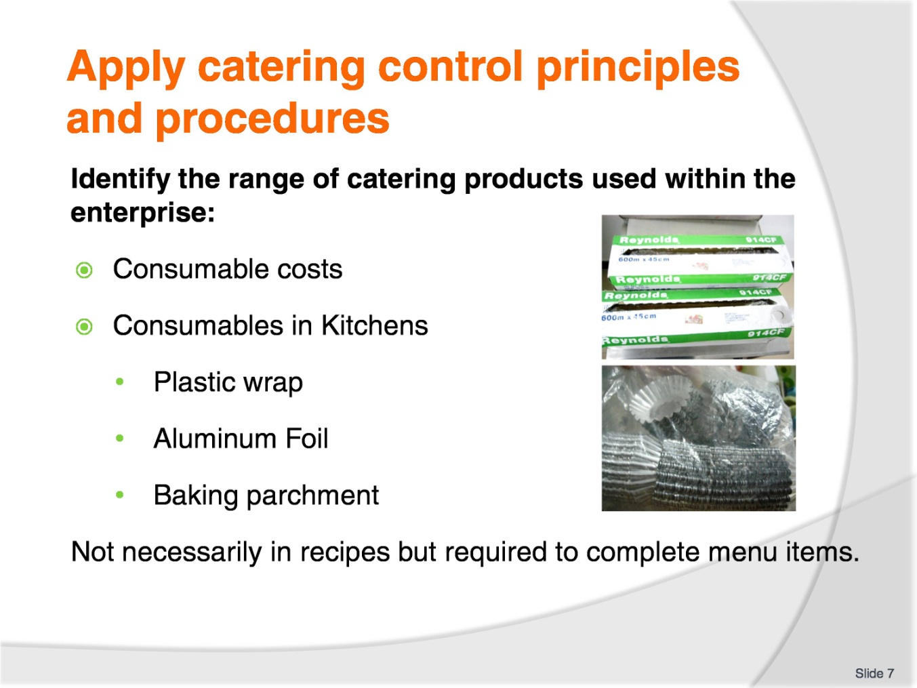
Slide No | Trainer Notes
Trainer to advise:
The amount of consumables required is hard to measure but the cost of supplying can be a significant amount when working in larger premises.
Usage needs to be accounted against the amount revenue that is taken from the production from that area of use.

Slide
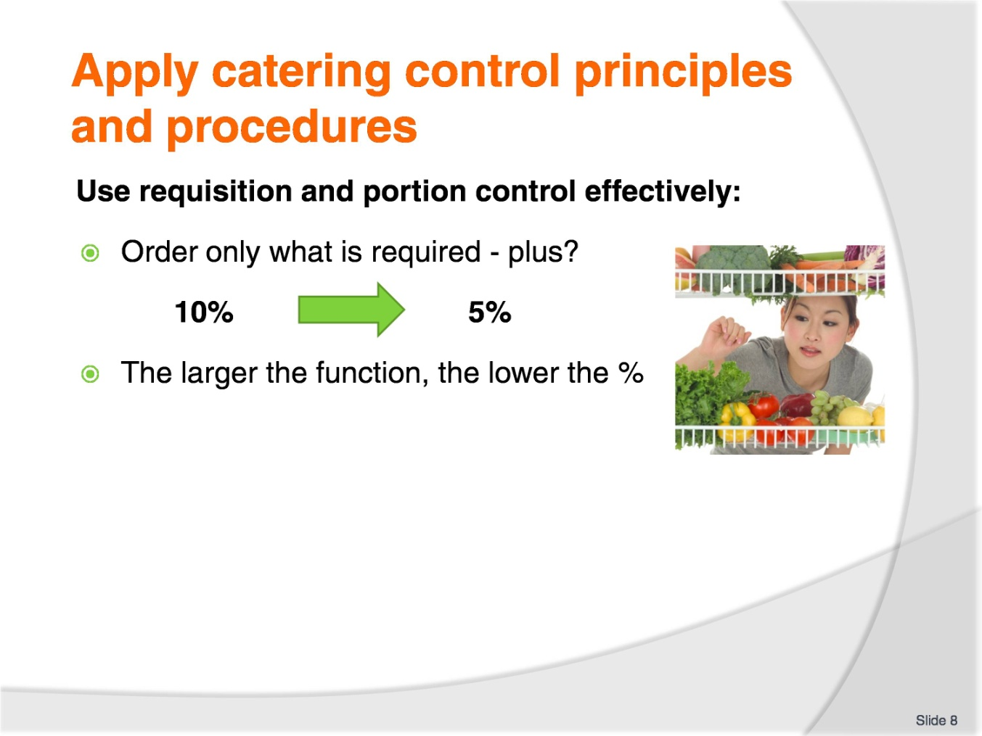
Slide No | Trainer Notes
Trainer to advise:
Ordering food for catering establishments is difficult. It is not a perfect science.
You can have a Standard recipe that states a set amount of food BUT?
The BUTs is about replacing food that is:
Ruined before it is cooked
Burnt in the cooking process
Plate of food is dropped before it is served to the customer.
Many things may cause the amount of food that is in the Standard Recipe to be incorrect; there is a shortfall.
Number 1 rule: never run out of food until the last customer is served.
So standard practice may be for 50 people order enough food for 55 plates.
200 people? Order enough food for 215 plates.
The costs for this fail safe process would allow for the extra food costs.
In a la carte restaurant service it is more the case when food for a particular dish is no longer available then it is taken off the menu. At least these customers will have alternative dishes to choose from.

Slide
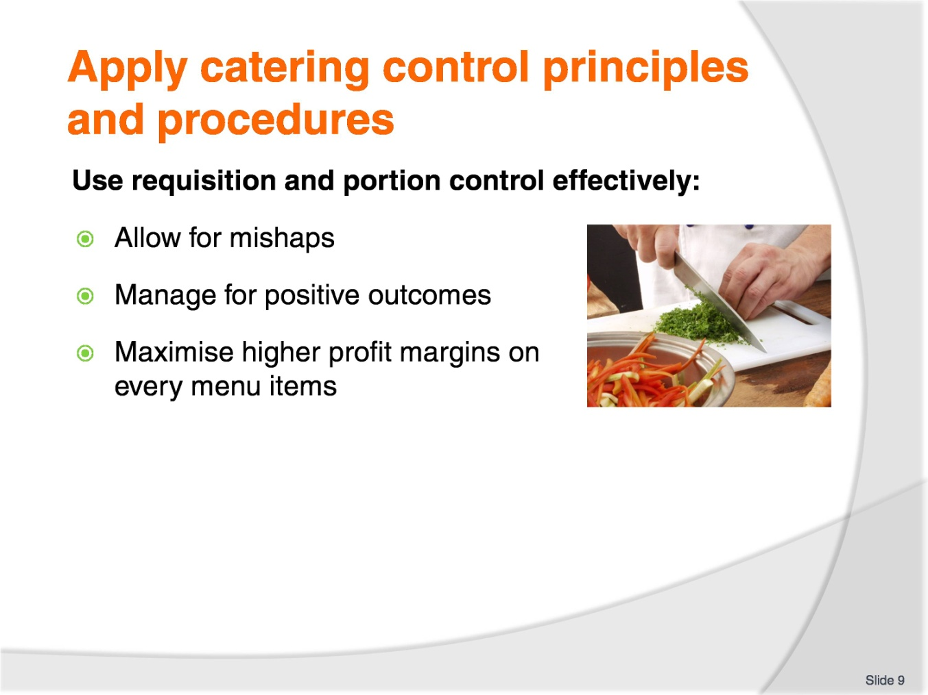
Slide No | Trainer Notes
Trainer to advise:
Ordering food for catering establishments is difficult. It is not a perfect science.
When ordering foods for menu item production it is generally a case of purchasing an amount of produce and obtaining maximum number of meals from that amount purchased.
Customers get upset if:
the portions are not all the same size
It does not taste the same as it did the last time they ate at your establishment
Your establishment charges more than the competition.
In all production situations there needs to be allowances made for mishaps and accidents.
Good management has these safeguards built in and manages to maximise returns with minimal losses.

Slide
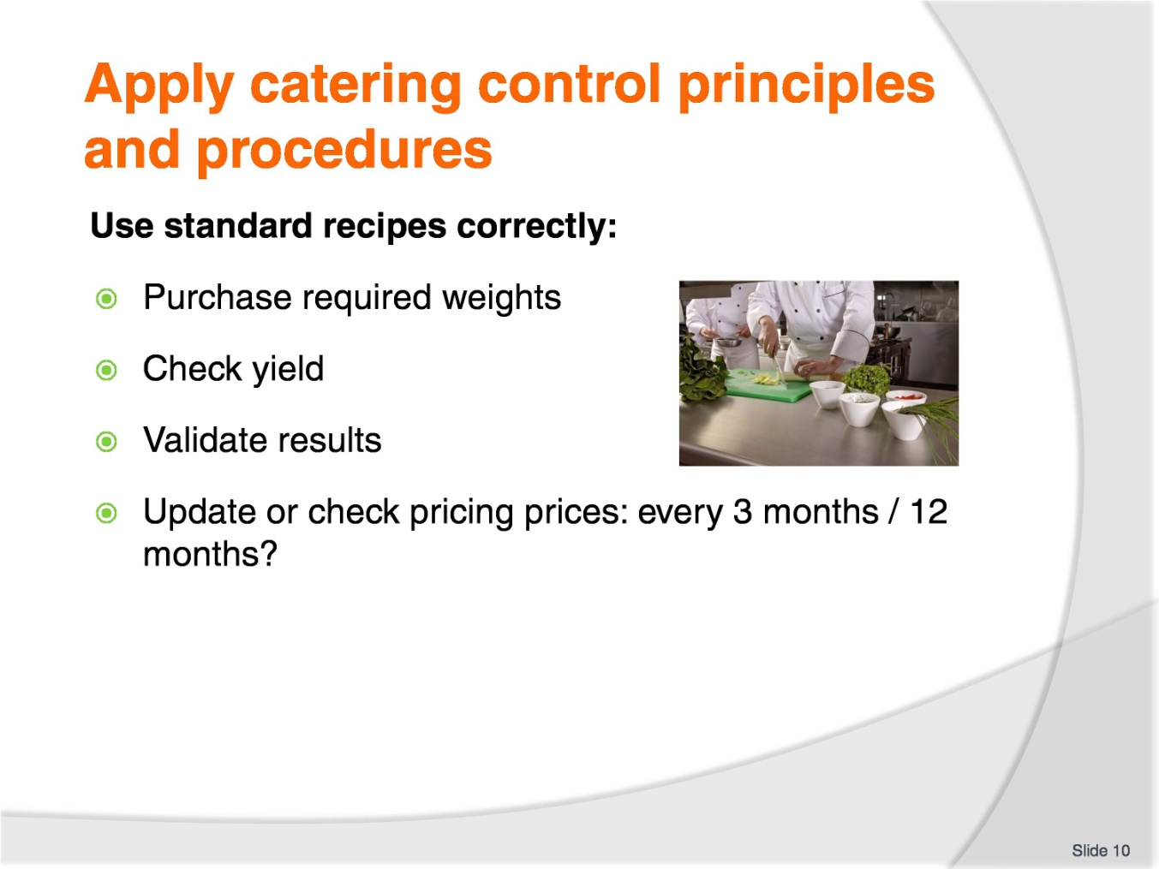
Slide No | Trainer Notes
Trainer to advise:
Following Standard recipes has built it safe guards.
Required yields will have a built in reserve.
Yield will have built in safe guards.
The safe guards will be:
Will all people trim and peel the same amount?
Will they all have the same skill base?
What will be the breakeven point of multiple people producing the recipe to equal the same result?
If a good cook has 8% wastage what will an average cook have when they clean meat from carcass 12%?
If 10 people did the same job, what is the end result?
Do they all get the same yield; 10 serves at 150gm each serve?
All these safe guards need to be built into a Standard Recipe.
Also how much have the prices changed?

Slide
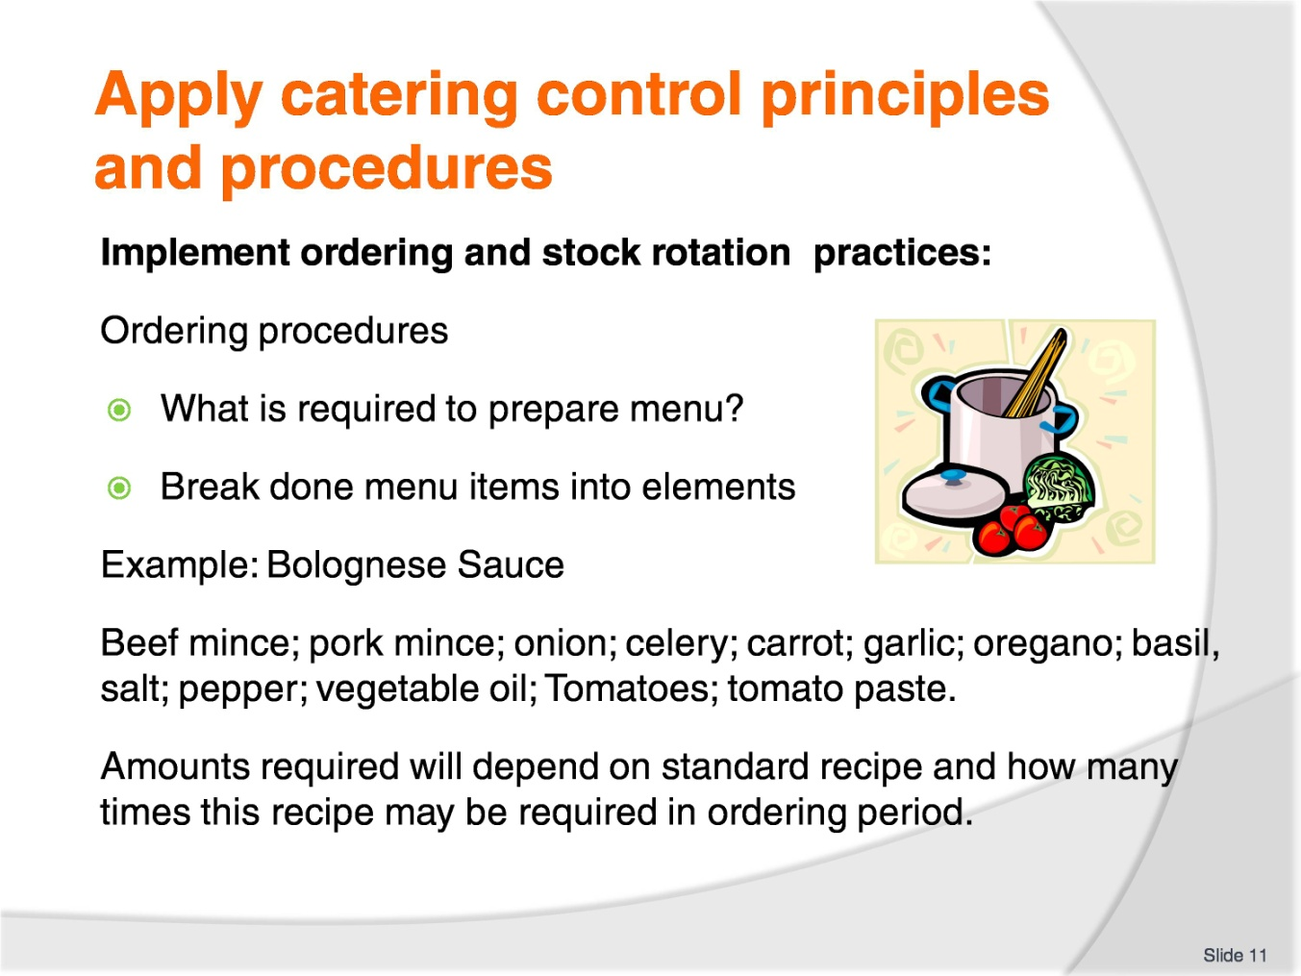
Slide No | Trainer Notes
Trainer to advise:
Determining how much stock to order is simple.
Standard recipes will produce a set amount of sauce or end product.
Remember: it is not just the Bolognese sauce that is required for the menu item.
What else?
Chopped parsley for garnish
Parmesan cheese
Pasta.
Think of everything!
Will it be take away or eat in?
Paper serviettes
Spoon and fork
Container to take product away
Carry bag for container.

Slide
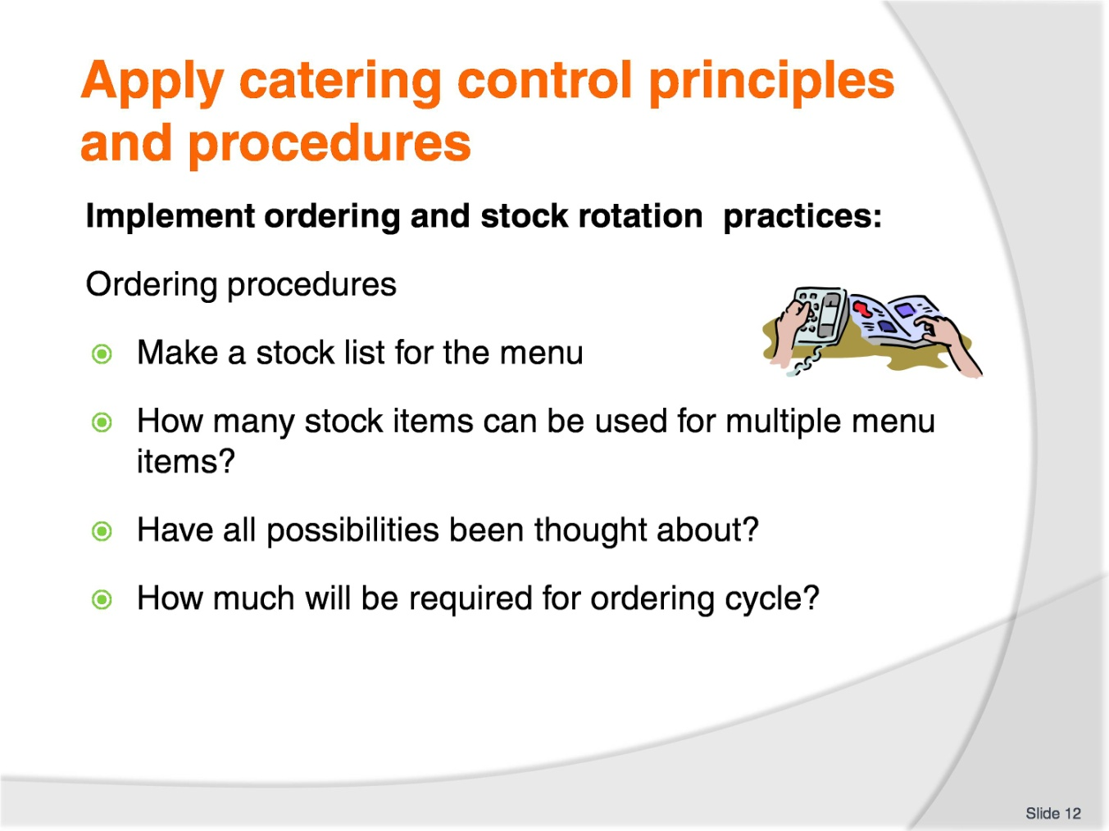
Slide No | Trainer Notes
Trainer to advise:
Determining how much stock to order is simple.
When a completed stock requirement list is completed.
Place order
Constant monitoring of stock levels is crucial for smooth operation of any business
Is ‘Par Stock’ system in operation?
Is it computerised?
Is it manual? Visual

Slide
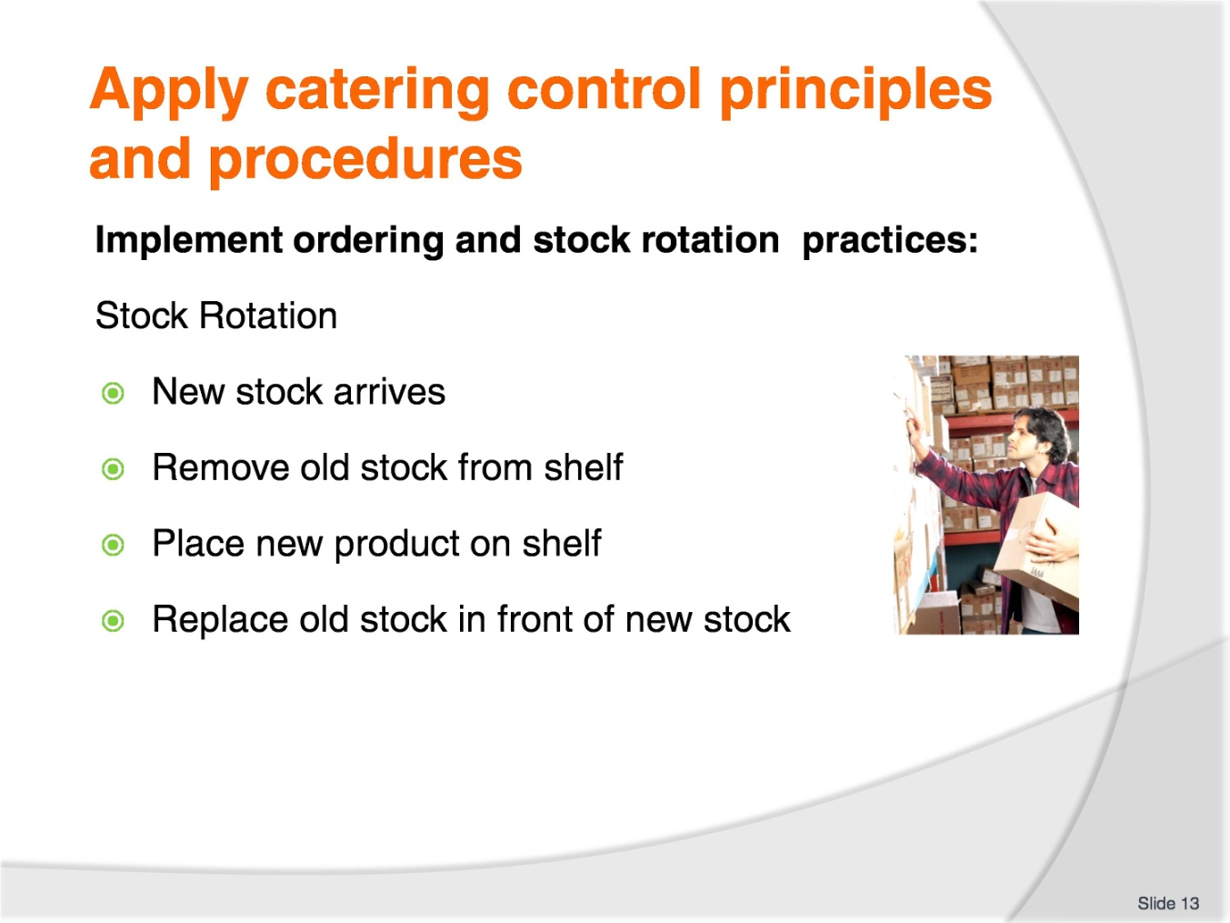
Slide No | Trainer Notes
Trainer to advise:
Stock rotation is basic.
NEVER place new stock in front of old stock when it is placed into the storage area.
When new stock arrives:
Remove old stock from storage shelf
Clean down shelf
Place new stock onto storage shelf
Replace old stock onto shelf in front of new stock
Check old stock for out of date or damage.

Slide
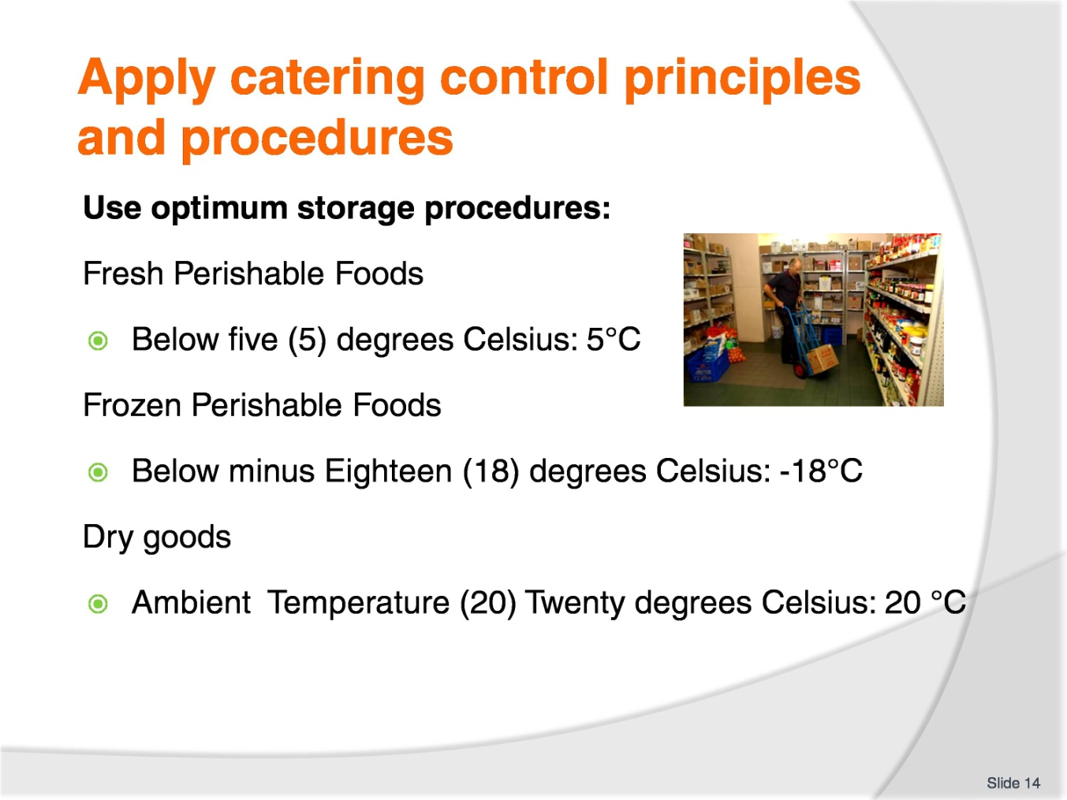
Slide No | Trainer Notes
Trainer to advise:
Fresh foods are best stored below 5 degrees Celsius for up to 3 days.
Purchase only what is required and use as soon as possible.
Frozen foods need to be stored below -18 degrees Celsius for time period required.
Frozen time will vary will all goods but stock should be rotated FIFO for efficient management of stock: Every 3 months; discard stock older than 3 months.
Some things can be frozen for longer but if you are carrying stock that has been in your freezer for that length of time then you have lost money.

Slide
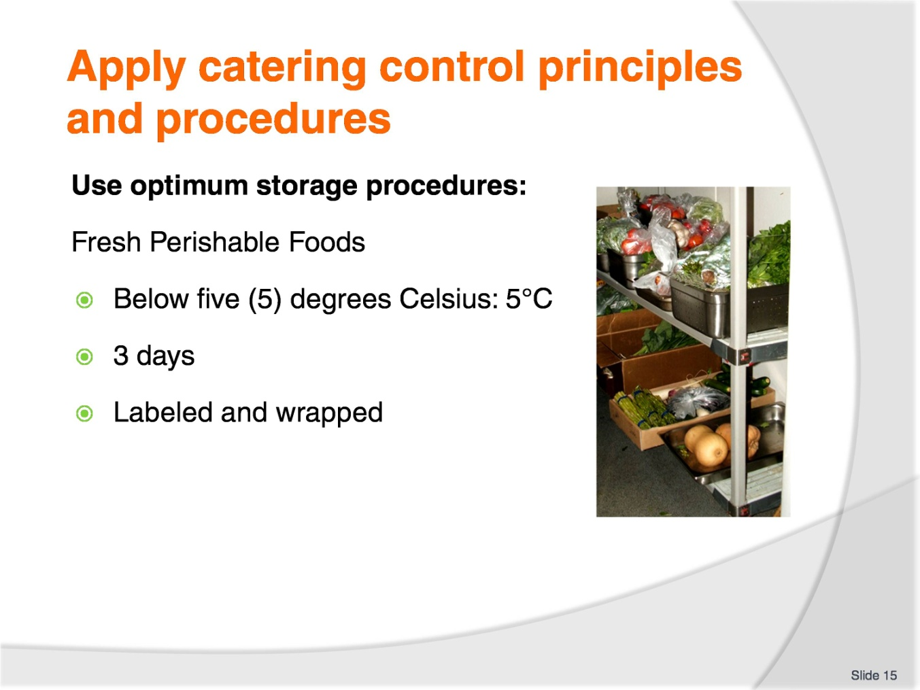
Slide No | Trainer Notes
Trainer to advise:
Fresh foods are best purchased as you need them.
Some busy hotels need to prepare several days ahead of time just because of the time factor. So processing several days ahead is just using resources more efficiently.
Some foods can be stored for longer than 3 days.
Failsafe point is 3 days. If fresh food is to be stored then store it for no more than 3 days; this will minimise to possible growth of bacteria to a dangerous level.
If it is kept chilled and protected from contamination (wrapped securely) then it will still be safe for human consumption with minimal risk.

Slide
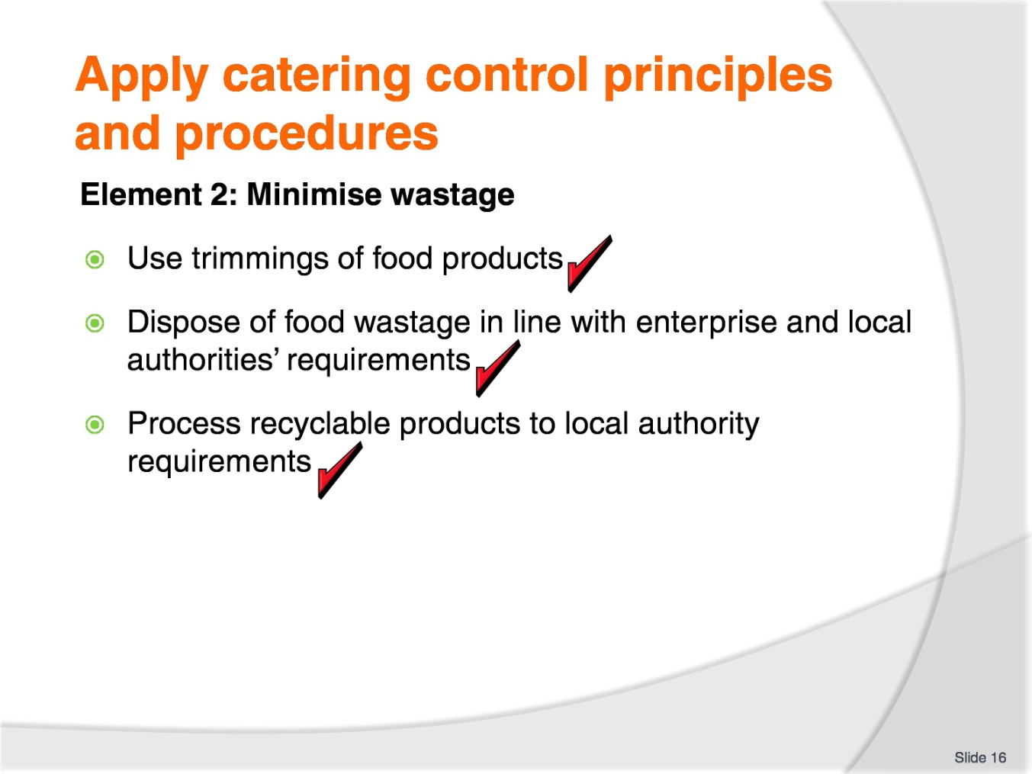
Slide No | Trainer Notes
Trainer to advise:
Trainer to relate performance criteria to element 2.
Performance criteria is the process by which the students training match the learning element.
The element is the skill.
To assess competency in the skill; the performance criteria is used to outline activities that can be used to assess competency.
The trainer should relate how the performance criteria are related to the element.
To be able to apply catering control principles and procedures, the students must be able to minimise wastage.
The student should be able to:
Use trimmings of food products
Dispose of food wastage in line with enterprise and local authorities’ requirements
Process recyclable products to local authority requirements.

Slide
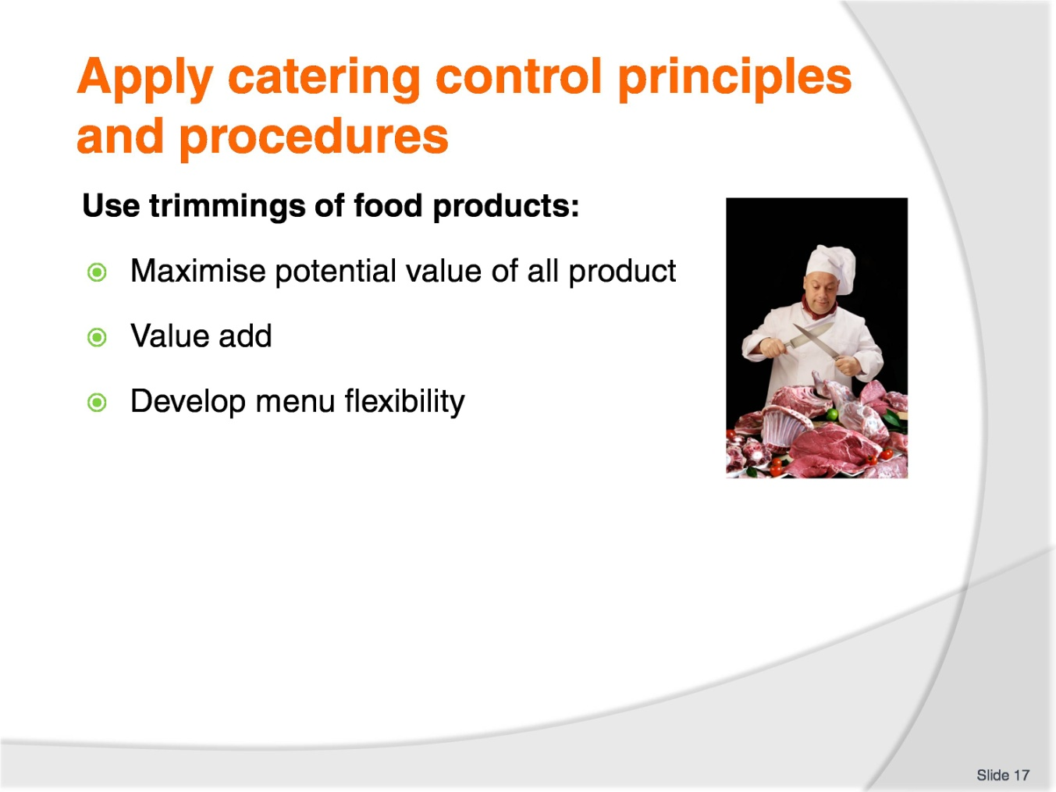
Slide No | Trainer Notes
Trainer to advise:
The use of trimmings and off cuts has always been an issue in the commercial kitchen.
The boss or bookkeeper sees all discarded food as potential loss of profit.
Apply total cost of purchases to usable product.
Some product has a lot of wastage, some has minimal wastage, some product everything is used.
Sometimes it is NOT cost effective to try and retrieve usable product from trimmings.
Sometimes the quality of the trimmings is not sufficient to pay a person’s time to retrieve usable product.
Skill is required and it is always up to the chef (the one in charge) to decide how the trimmings will be treated and where and how they are to be extracted.
Using trimmings can increase the profit margins if the costs are applied correctly.
Menu flexibility can also be improved if the use of the trimmings can be applied.
BUT, sometimes the ‘special dish’ developed to utilise the trimmings become becomes so popular that extra product has to be purchased to meet the popularity of the new menu item.
It is all a balance.

Slide
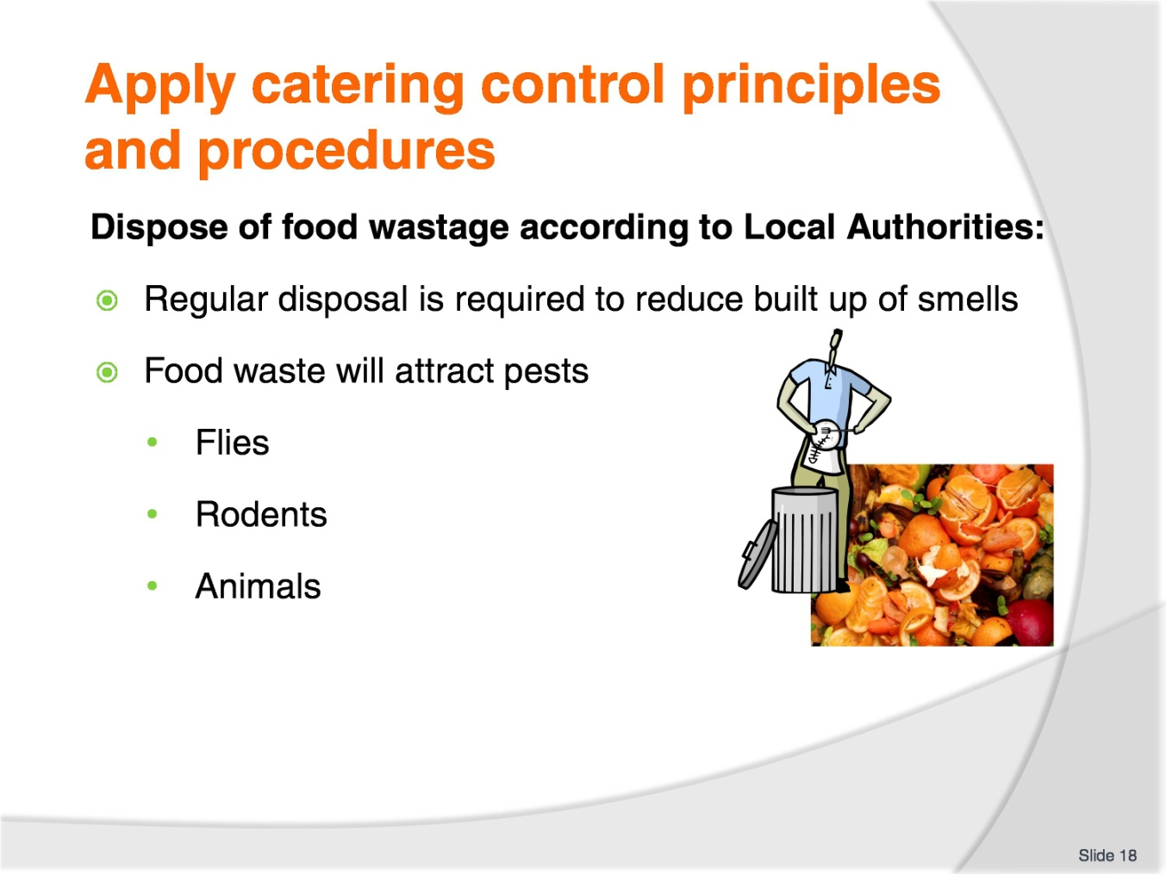
Slide No | Trainer Notes
Trainer to advise:
Food waste is a part of life.
How it is managed is vital to the safety of the community.
Food enterprises have to comply with the rules and regulations of the Local Government Authority.
Accumulation of food waste will bring disease and sickness to the community as well as unwanted smells and odours.

Slide
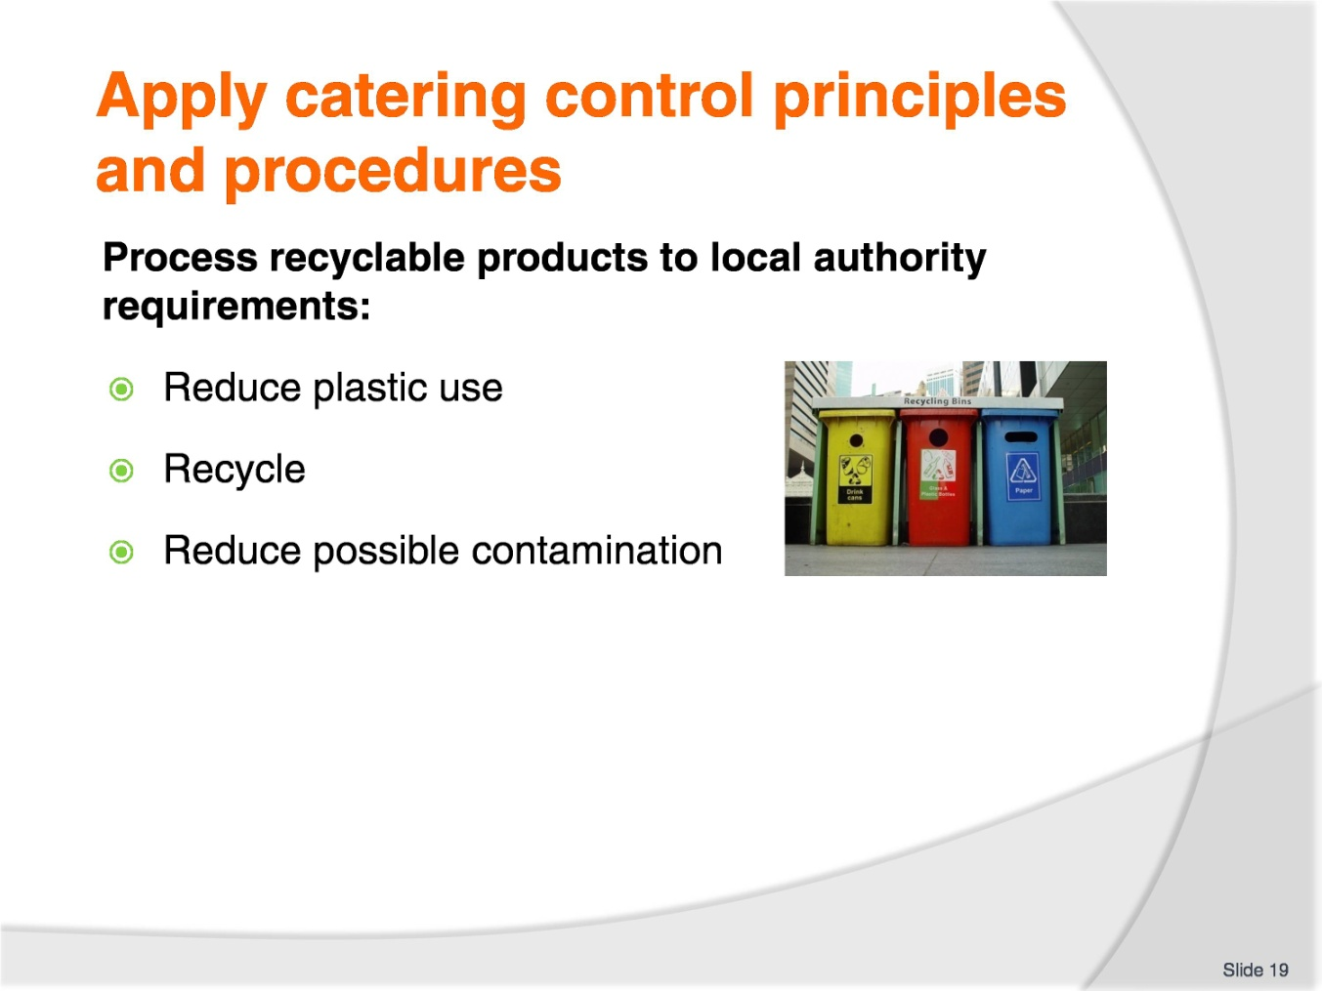
Slide No | Trainer Notes
Trainer to advise:
Recycling is a way of maximising the use of products that otherwise end up as landfill.
Some waste products can poison the land and then contaminate the food chain.
Contamination of the food chain occurs when chemical that come out of plastics and used oils as they begin to breakdown in the soil and these chemical then leach into any foods that are grown in that soil.
Contaminated soil is rained upon and the water soaks into the soil and then goes into underground aquifers where ground water is drawn into drinking water.
Rain falls onto contaminated soil and runs into the rivers.
Taking the plastics and reusing them will reduce the level of soil contamination and leave the soil better suited to producing healthy foods.
Metals and glass in the landfill also cause damage.
Old cooking oils from deep frying needs to be recycled into detergents or Bio-Diesel, rather than being poured down the sink or being dumped into the soil or water table or river systems.
Keep the environment healthy. Recycle.

Recommended training equipment
Calculator
Writing materials
Whiteboard
Computer (if excel program based)
Standard requisition forms
Stock ordering sheets
Stock take sheets
Standard recipes
Price list of commodities used
Wastage sheets
Local Government requirements for disposal of waste products
Local Government requirements for recycling of waste products

Instructions for Trainers for using
PowerPoint – Presenter View
Connect your laptop or computer to your projector equipment as per manufacturers’ instructions.
In PowerPoint, on the Slide Show menu, click Set up Show.
Under Multiple monitors, select the Show Presenter View check box.
In the Display slide show on list, click the monitor you want the slide show presentation to appear on.
Source: http://office.microsoft.com
Note:
In Presenter View:
You see your notes and have full control of the presentation.
Your trainees only see the slide projected on to the screen.
More Information
You can obtain more information on how to use PowerPoint from the Microsoft Online Help Centre, available at: http://office.microsoft.com/training/training.aspx?AssetID=RC011298761033
Note Regarding Currency of URLs
Please note that where references have been made to URLs in these training resources trainers will need to verify that the resource or document referred to is still current on the internet. Trainers should endeavour, where possible, to source similar alternative examples of material where it is found that either the website or the document in question is no longer available online.

Appendix – ASEAN acronyms
AADCP | ASEAN – Australia Development Cooperation Program.
ACCSTP | ASEAN Common Competency Standards for Tourism Professionals.
AEC | ASEAN Economic Community.
AMS | ASEAN Member States.
ASEAN | Association of Southeast Asian Nations.
ASEC | ASEAN Secretariat.
ATM | ASEAN Tourism Ministers.
ATPMC | ASEAN Tourism Professionals Monitoring Committee.
ATPRS | ASEAN Tourism Professional Registration System.
ATFTMD | ASEAN Task Force on Tourism Manpower Development.
CATC | Common ASEAN Tourism Curriculum.
MRA | Mutual Recognition Arrangement.
MTCO | Mekong Tourism Coordinating office.
NTO | National Tourism Organisation.
NTPB | National Tourism Professional Board.
RQFSRS | Regional Qualifications Framework and Skills Recognition System.
TPCB | Tourism Professional Certification Board.







